Github : https://github.com/mankumarbhalodiya/Digital-Signal-and-Image-Processing
AIM: Design FIR filter with windowing method.
Code :
import numpy as np
import matplotlib.pyplot as plt
from scipy.signal import firwin, freqz
N = 31
Fs = 10000
low = firwin(N, 3000, window='hann', fs=Fs)
high = firwin(N, 3000, window='hann', pass_zero='highpass', fs=Fs)
band = firwin(N, [3000, 4500], window='hann', pass_zero='bandpass', fs=Fs)
stop = firwin(N, [3000, 4500], window='hann', pass_zero='bandstop', fs=Fs)
filters = [low, high, band, stop]
titles = ['Low Pass', 'High Pass', 'Band Pass', 'Band Stop']
plt.figure(figsize=(10, 8))
for i in range(4):
f, H = freqz(filters[i], worN=2048, fs=Fs)
plt.subplot(2, 2, i + 1)
plt.plot(f, 20 * np.log10(np.maximum(abs(H), 1e-10)))
plt.title(titles[i])1
plt.xlabel('Frequency (Hz)')
plt.ylabel('Magnitude (dB)')
plt.grid()
plt.tight_layout()
plt.show()
plt.figure(figsize=(10, 8))
for i in range(4):
plt.subplot(2, 2, i + 1)
plt.stem(filters[i])
plt.title(titles[i])
plt.xlabel('Sample')
plt.ylabel('Amplitude')
plt.grid()
plt.tight_layout()
plt.show()
plt.figure(figsize=(10, 8))
for i in range(4):
f, H = freqz(filters[i], worN=2048, fs=Fs)
plt.subplot(2, 2, i + 1)
plt.plot(f, np.unwrap(np.angle(H)))
plt.title(titles[i])
plt.xlabel('Frequency (Hz)')
plt.ylabel('Phase (Radians)')
plt.grid()
plt.tight_layout()
plt.show()
Output :
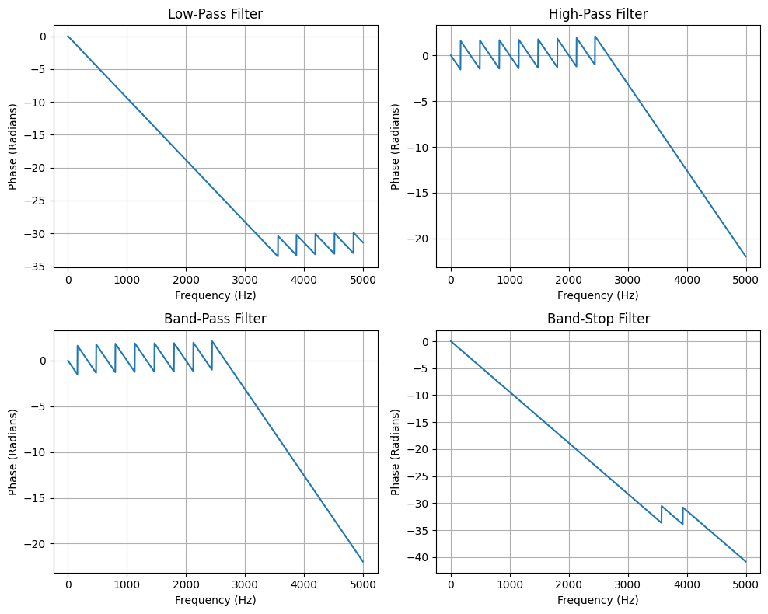

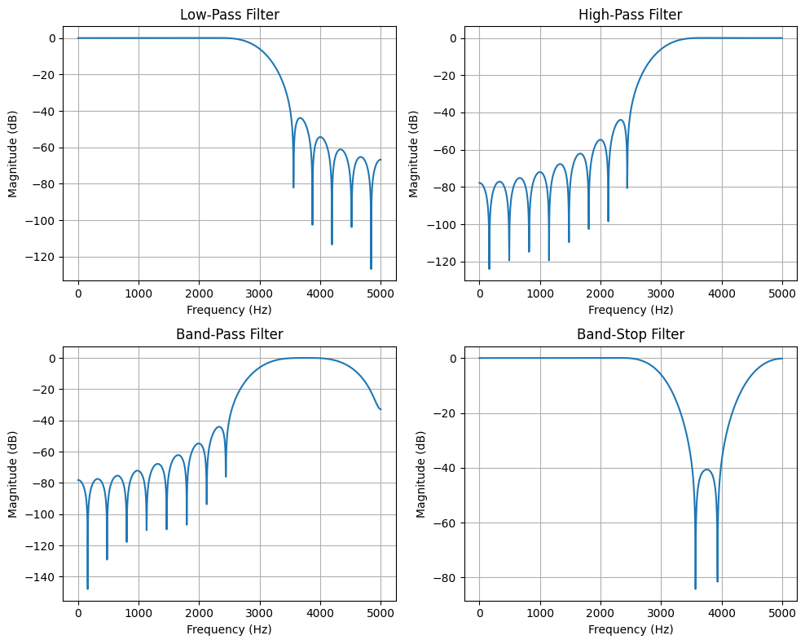

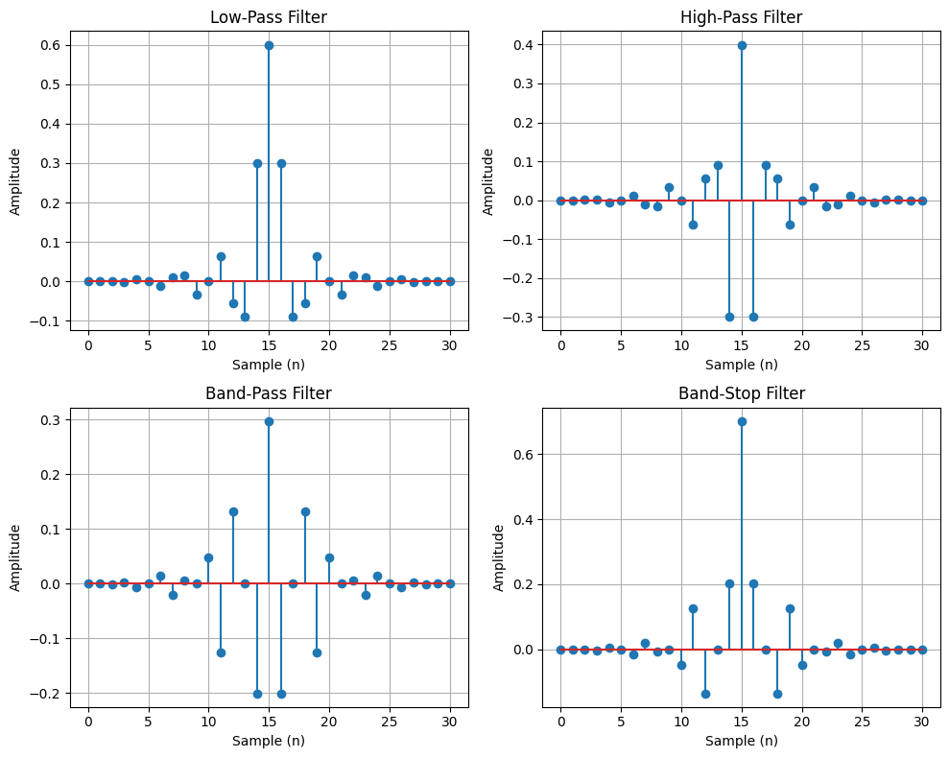
Music Anylysis Code :
import numpy as np
import matplotlib.pyplot as plt
import librosa
from scipy.io import wavfile
from scipy.signal import firwin, lfilter

song, Fs = librosa.load("Todh___Prince_Narula___Munawar__Official_Video____Jaymeet___Rony_Ajnali___Gill_Machhrai(128k).mp3", sr=None)
N = 31
low = firwin(N, 3000, window='hann', fs=Fs)
high = firwin(N, 3000, window='hann', pass_zero='highpass', fs=Fs)
band = firwin(N, [3000, 6000], window='hann', pass_zero='bandpass', fs=Fs)
stop = firwin(N, [3000, 6000], window='hann', pass_zero='bandstop', fs=Fs)
filters = [low, high, band, stop]
titles = ['Low Pass', 'High Pass', 'Band Pass', 'Band Stop']
files = ['low_pass.wav', 'high_pass.wav', 'band_pass.wav', 'band_stop.wav']
plt.figure(figsize=(10, 8))
for i in range(4):
output = lfilter(filters[i], 1, song)
plt.subplot(4, 1, i + 1)
plt.plot(np.arange(len(output)) / Fs, output)
plt.title(titles[i])
plt.xlabel('Time (seconds)')
plt.ylabel('Amplitude')
plt.grid()
wavfile.write(files[i], Fs, (output / (np.max(np.abs(output)) + 1e-10) * 32767).astype(np.int16))
plt.tight_layout()
plt.show()
print("All filtered songs saved!")
Output :
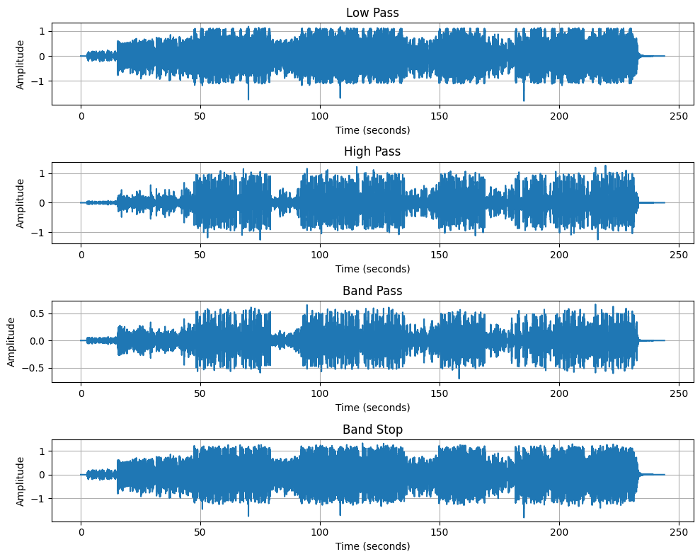
Conclusion : The four FIR filters were successfully applied to the song using Python. The low-pass filter reduces high-frequency sounds, while the high-pass filter reduces low-frequency sounds. The band-pass filter keeps sounds between 3 kHz and 6 kHz, and the band-stop filter removes sounds in that range. After filtering, all four audio files were saved and their waveforms were displayed for comparison.

